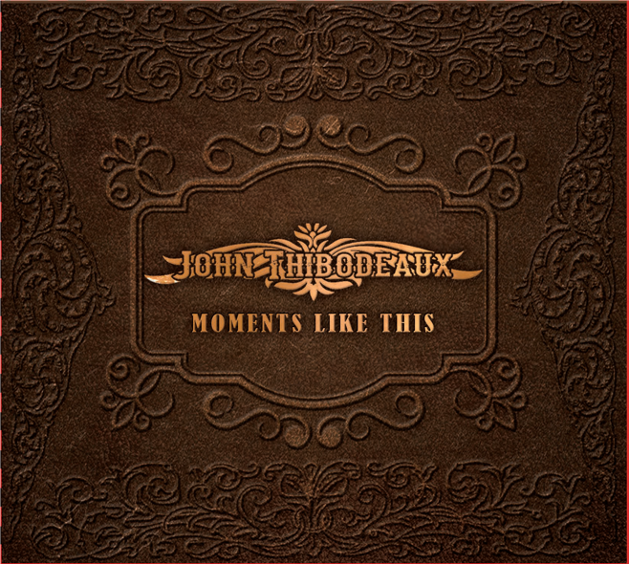
John Thibodeaux
“Buzzed On Loving You”

Track Time: 00:02:28

Available On: Mar 8, 2018

Available For: Stream | Download

Album: Moments Like This

ISRC: USX241700269

Origin: Beaumont, Texas Representation:

Genre: Country MusicSmith Records: John Thibodeaux

Label: MusicSmith Records/SJM Nashville Email: johnthibodeauxmusic@yahoo.com

Website: www.johnthibodeaux.net Press/Booking: Misty Colicher

Contact: 409-201-9084 Email: johnthibodeauxmusic@yahoo.com

John Thibodeaux
From the Beaumont area of Southeast Texas, John Thibodeaux describes himself as a “Texan seasoned with some Cajun spice!” At the age of 14, John started playing with various local and regional bands, then in 2007, formed the John Thibodeaux Band where he began writing original music to suit his style. John’s debut EP “Simple Life” produced a Top 40 Texas Chart single. However, his music career was suddenly paused due to his deployment to the war in Afghanistan in 2015. Upon His return home, the John Thibodeaux Band was revived and is now stronger than ever.
John just recently returned to the studio with Grammy winning producer Robb Tripp, where they produced his first full length studio album, “Moments Like This.” John’s new album is a culmination of emotions brought on by true life events, of which John wrote 7 songs. This new project brings us John’s brand new single, “Buzzed On Loving You.” A refreshing song with the country sounds of Electric and Steel Guitars complimenting the smooth, Texas draw of John Thibodeaux’s voice.

